# What we will be doing as part of this exercise:

1. Create War artifact
2. Create Dockerfile to build Docker Image
3. Upload Image to DockerHub (Public Repository)
4. Download and Run the Web application in another/same machine with docker commands.

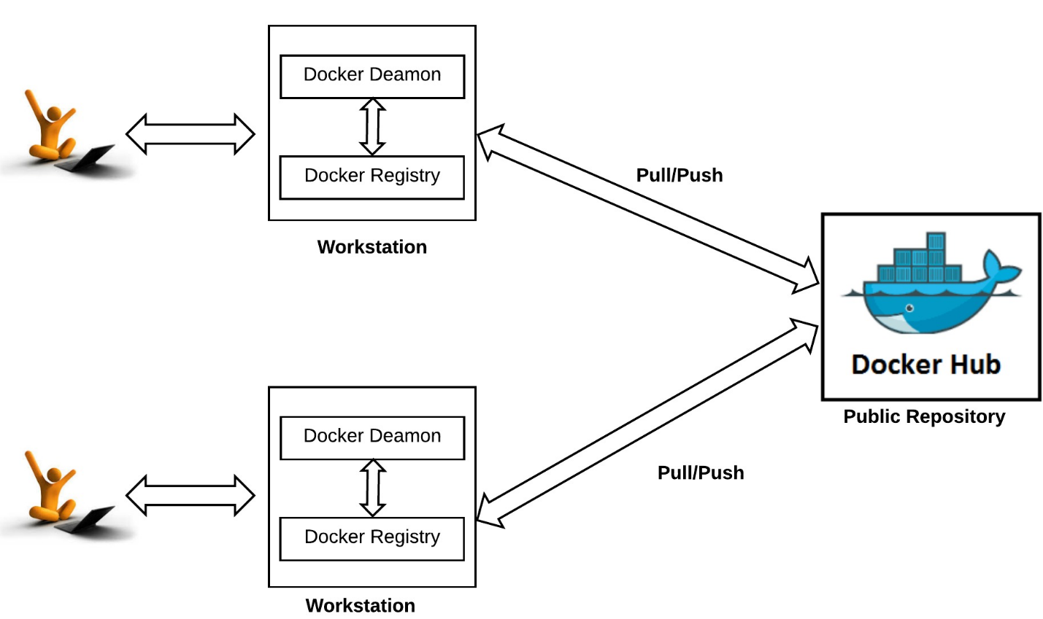

# Assignment 1:

1. Download or Clone the following repository from Git, this contains infrastructure code and source code to get started.

<https://github.com/mbzama/docker-training>

1. Extract (or) Copy the “docker-training” directory to “C:/Users/{User}”
2. Import “hr-web” project into IDE (Or) Just run the Maven/ANT commands to build the required artifact.
3. Please change the output folder in “pom.xml” to reflect your local directory. i.e., C:/Users/{User}/docker-training/infrastructure-code/hr-app/hr-web

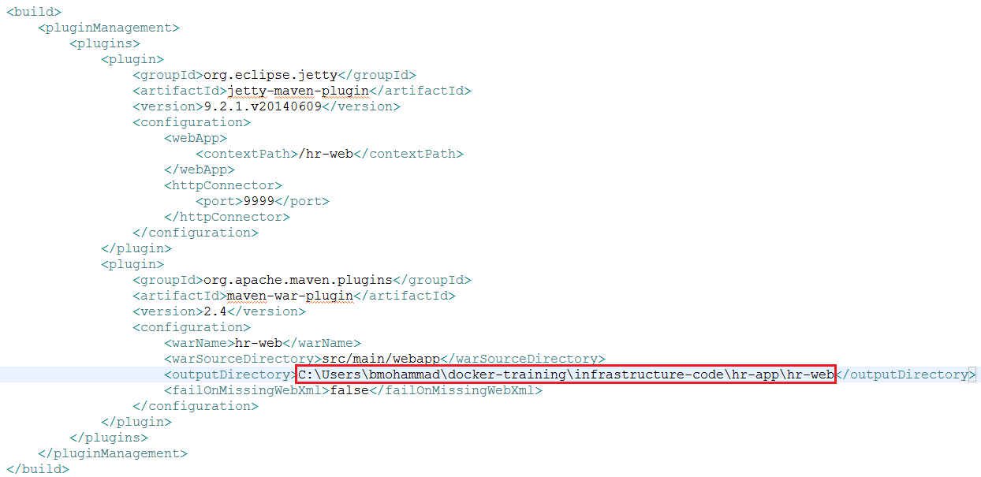

1. Run this command to build/copy the war artifact: **mvn clean install**
2. Create Dockerfile with the following instructions:

FROM tomcat

ADD hr-web.war /usr/local/tomcat/webapps/

EXPOSE 8080

CMD ["catalina.sh", "run"]

1. Run the below command to run the web application in a Docker container:

**update_web.sh**

1. Access the Web application using this url:

<http://192.168.99.100:9090/hr-web/>

1. Access the application logs using this command:

**docker logs -f hr-web-container**

1. Please make sure to change the default Docker hub credentials and Tag from this script:

**upload_web_image.sh**

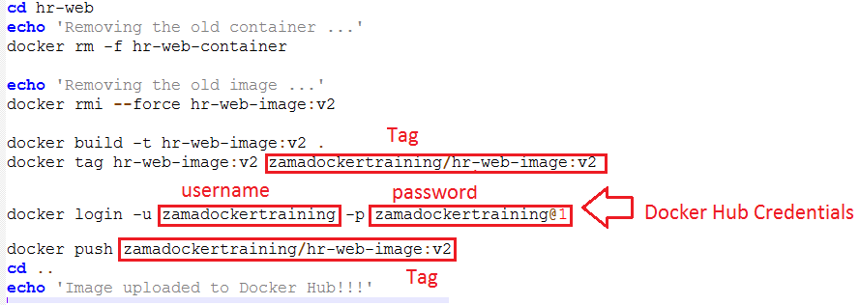

1. Go to Docker Hub and verify the image:

<https://hub.docker.com/r/zamadockertraining/hr-web-image/tags/>

